New Delhi, India

April 17, 2024



DATA MANAGER GUIDE

*India Electric Mobility Index (IEMI)*

**Table of Contents**

***1.0*** ***INTRODUCTION 4***

***2.0 LOGIN 5***

***3.0 DASHBOARD 6***

***4.0 AREA 7***

**4.1 EXPORT 7**

**4.2 IMPORT 9**

**4.3 ADD 10**

***5.0 SECTOR 11***

**5.1 EXPORT 11**

**5.2 IMPORT 13**

**5.3 ADD 14**

***6.0 INDICATOR 15***

**6.1 EXPORT 15**

**6.2 IMPORT 17**

**6.3 ADD 18**

***7.0 INDICATOR METADATA 24***

**7.1 EXPORT 24**

**7.2 IMPORT 26**

**7.3 ADD 27**

***8.0 DATA ENTRY 29***

**8.1 EXPORT 29**

**8.2 IMPORT 31**

**8.3 ADD 32**

***9.0 DATA AAPROVE 34***

***10.0 ENTITY REGISTRATION 35***

**10.1 EXPORT 35**

**10.2 IMPORT 37**

**10.3 ADD 38**

***11.0 RESOURCE 40***

***12.0 USER 42***

**12.1 USER AND PERMISSION 35**

**12.2 USER 35**

***13.0 LOGS 44***

# 1.0 INTRODUCTION

This user manual is developed to help the data administrators to understand the use of Data Manager application and its modules. This application will only be accessed to the users with valid login credentials.

The Data Manager application comprises of various data management modules. These modules allow the creation and management of the data and their elements.

**NOTE:** Valid login credentials are required to access the Data Manager application

The Data Manager application contains the following modules -

1. Dashboard
2. Area
3. Sector
4. Indicator
5. Indicator Metadata
6. Data Entry
7. Data Approve
8. Entity Registration
9. Resource
10. Access Control
11. Logs

Each of these modules are explained in detail in the following chapters.

# 2.0 LOGIN

The IEMI Data Manager application can be accessed through a web browser (recommended browser - Google Chrome latest version). Enter the URL <https://iemi.itechmission.org/> in the web browser. Enter administrator login credentials and correct captcha. Click on the **Login** button (see figure below).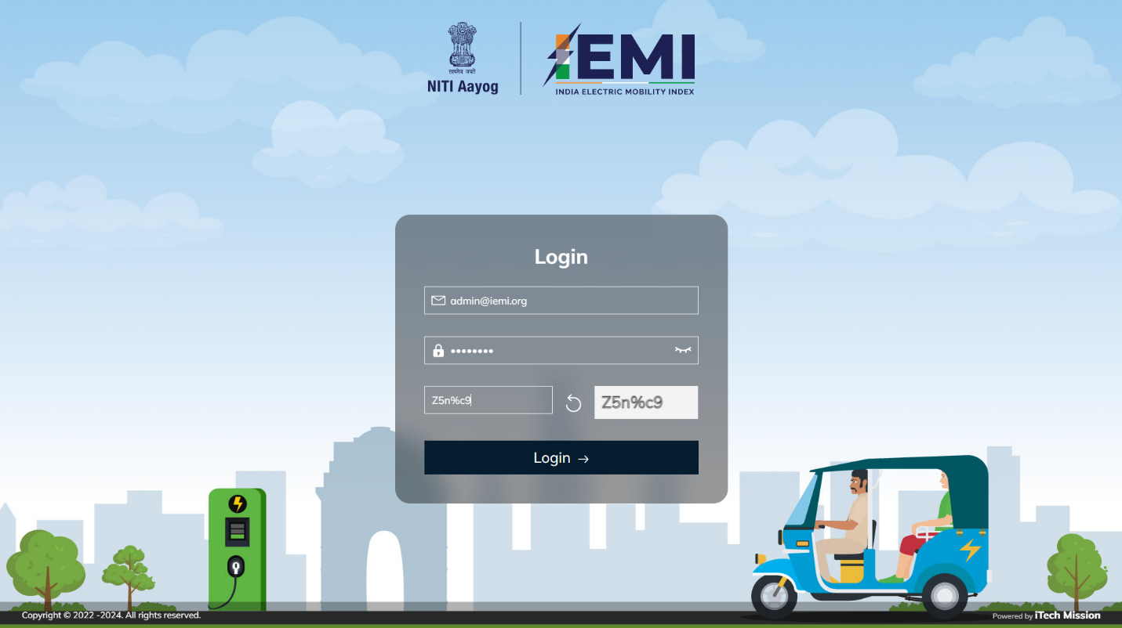

# 3.0 DASHBOARD

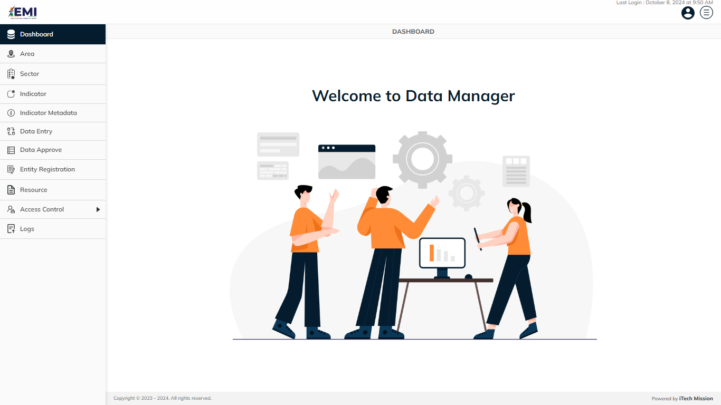The first module after successful login is **Dashboard.**

# 4.0 AREA

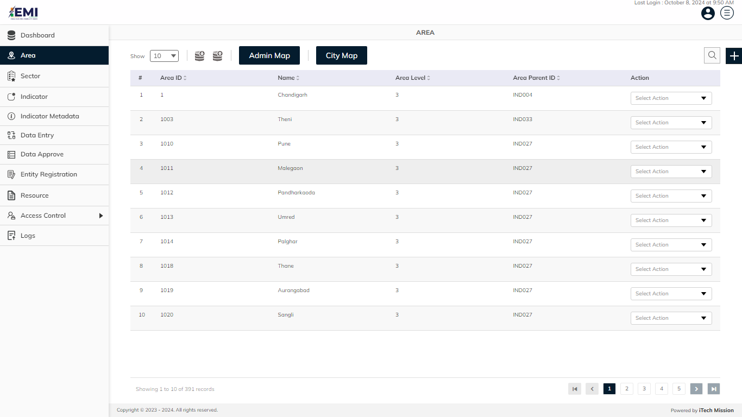Click on the **Area** menu option available in the left panel to access this module. This module allows to manage area master list. You will have options to export and import an area template , import Area Map and City Map, add new area, view the list of existing areas, sort the list, search area from the list, edit and enable/disable existing areas (see below figure).

## **4.1 EXPORT**

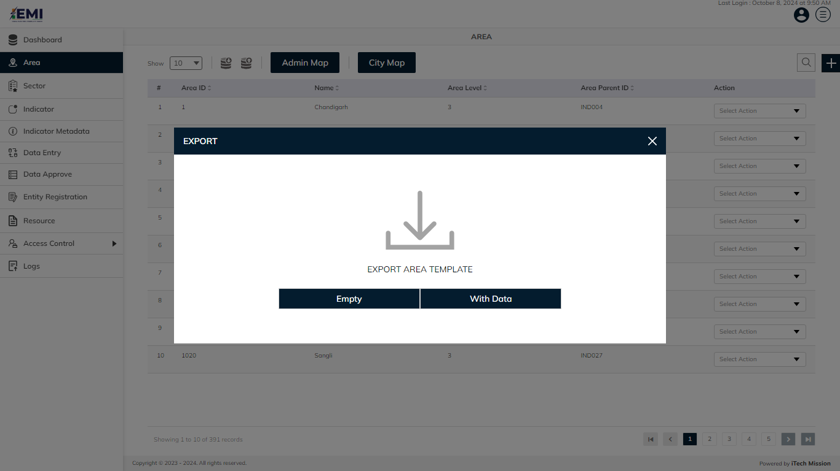Click on the **Export** button to download the empty area template and the area master list (see below figure).

You can use this option to create an area template structure. Below is the structure that you will find in the empty template.

|  |  |
| --- | --- |
| **Area ID** | A unique area identification that associates the area to its map |
| **Area Name** | Area Name assigned to an area. |
| **Area Level** | The level number assigned in the area hierarchy. |
| **Area ParentID** | AreaID of the parent area. |
| **Area Group** | Group of the area. |

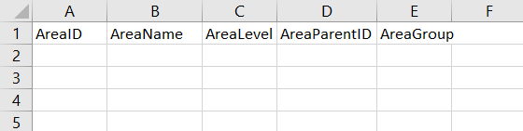Click on the **Empty** option to download an empty area template (see below figure). The area list is imported and exported in the CSV (Comma Separated Value) file format.

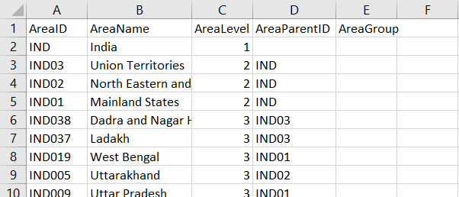Click on the **With Data** option to download the area master list (see below figure).

## **4.2 IMPORT**

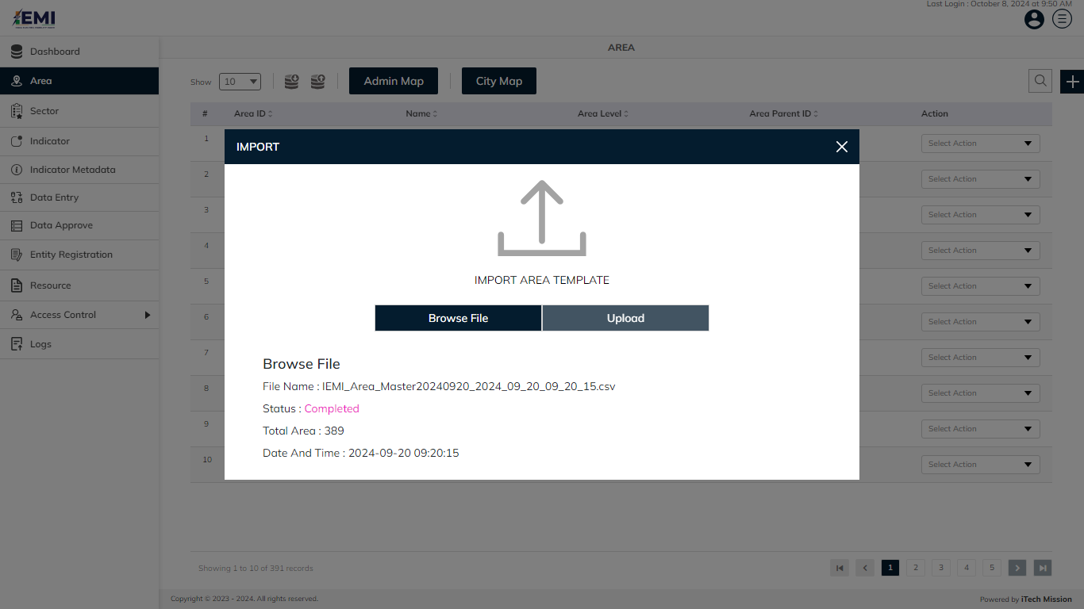Click on the **Import** button to browse the file and upload the area master list into the database (see below figure).

To upload the area into the database first enter the area structure in the template as explained above and then click on the **Browse File** button to select the template. Now, click on the **Upload** button to start the import process. During the import process, the records which contains blank entries, entries with special characters and duplicate entries are not imported in the database.

A Last Upload summary will appear after the import process which provides the count of successfully imported records out of the total records. An error log will be generated to report on unsuccessfully imported records which you can access from the **Logs** module.

Click on **Admin Map** to browse the file and upload the State Map into the database. **Admin Map** is uploaded If there is any change in the state map, like a new city is introduced then you have to edit the geo json, add that city, and reupload.

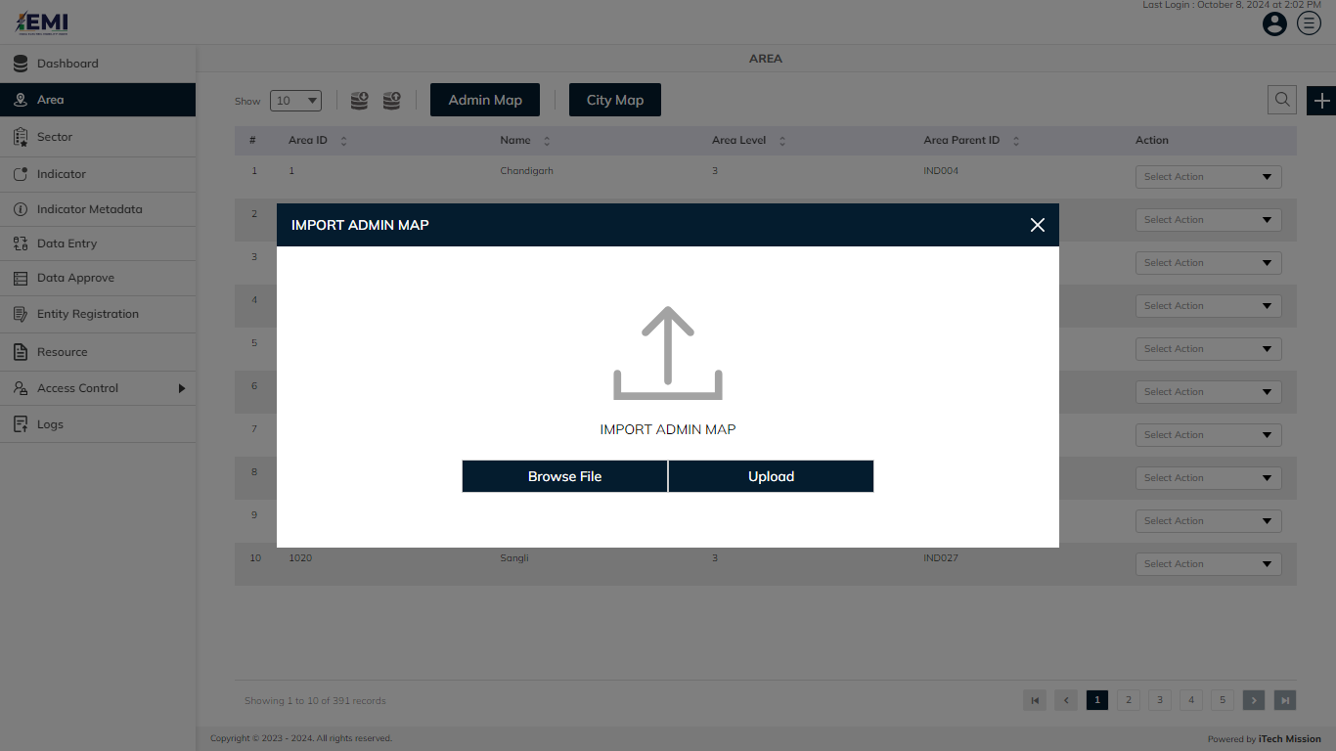Click on **City Map** to browse the file and upload the State Map into the database. **City Map** is uploaded if a new start-up or manufacturing is added in the city, and then this city is added in json, and reuploaded. (see figure below)

## **4.3 ADD**

Click on the **Plus** button available at the top right corner and enter the following information to add a new area.

* Select **Parent Area**
* Enter **Area ID**
* Enter area **Name**

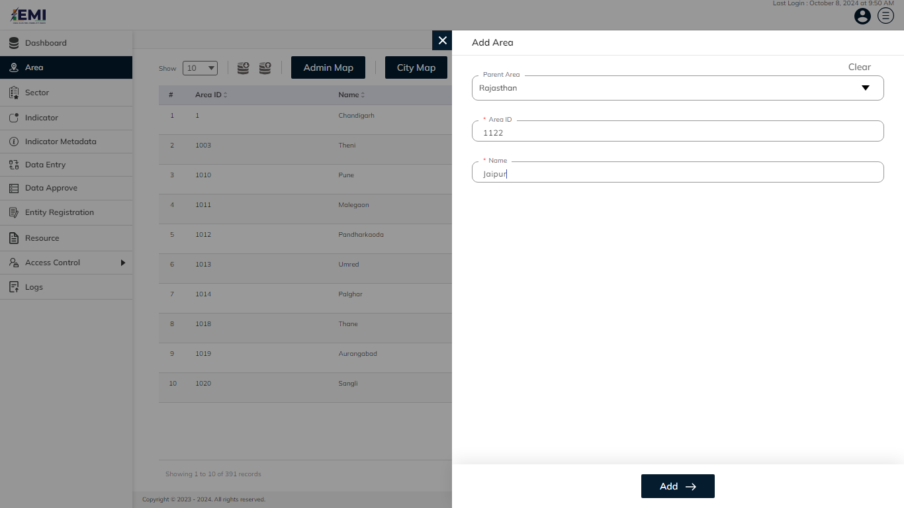Blue color details are mandatory to be entered. Click on the **Add** button to save and confirm. You can now view the new area added in the area list.

Click to select the **Edit** option available in the action dropdown to edit the details of the selected area. Edit the required detail and click on the update button to save and confirm.

Click to select the **Enable/Disable** option available in the action dropdown to show or hide the specific area. The hidden area will not be shown in the list of areas overall the application.

# 5.0 SECTOR

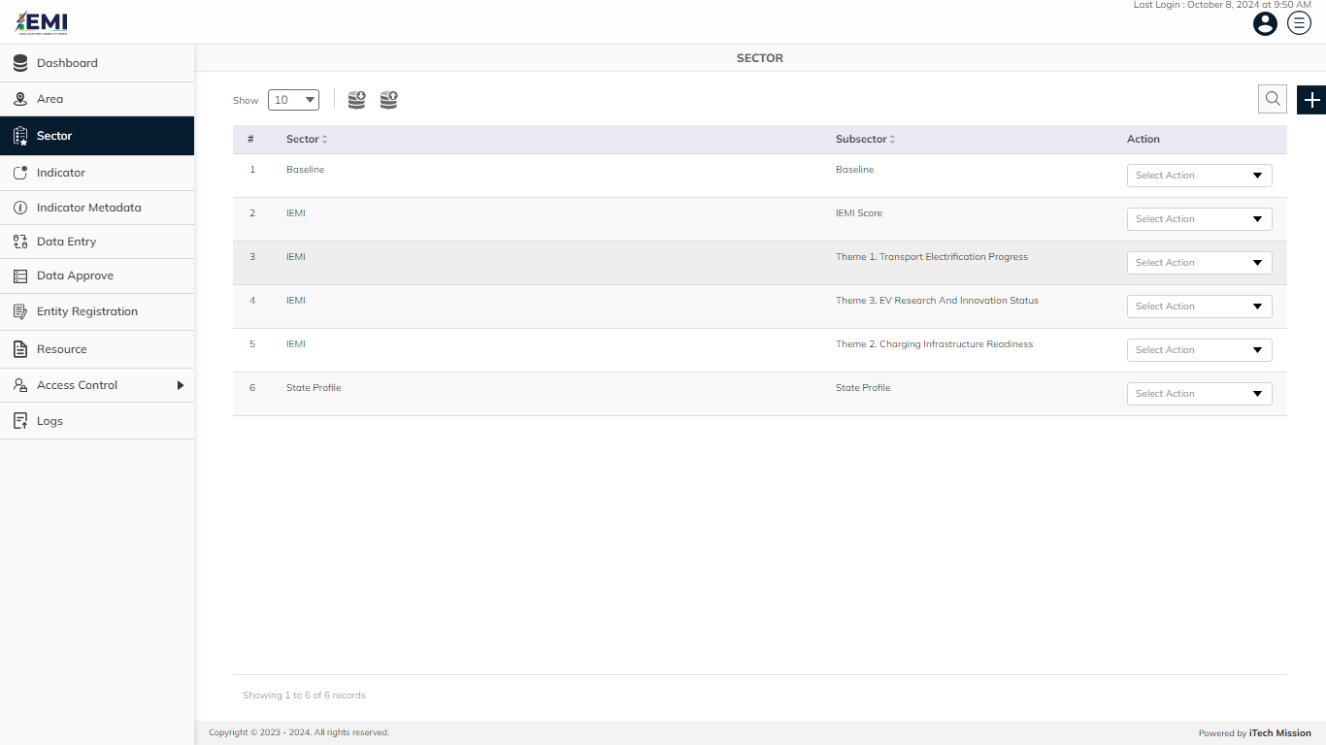Click on the **Sector** menu option available in the left panel to access this module This module allows you to manage the sector master list. You will have options to export and import sector template, add new sectors, view the list of existing sectors, sort the list, search sectors from the list, edit and enable/disable existing sectors (see below figure).

## **5.1 EXPORT**

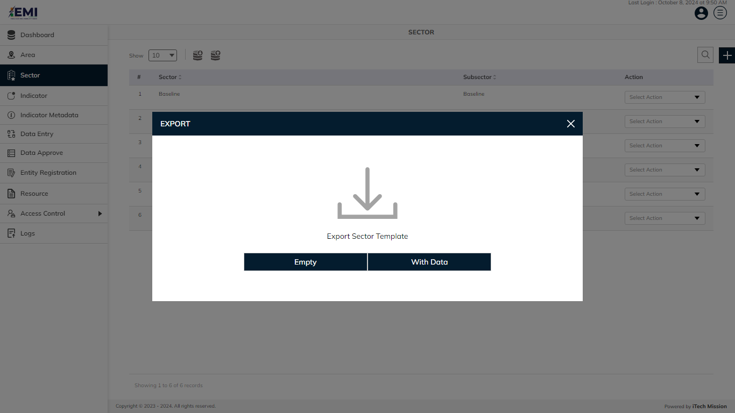Click on the **Export** button to download the empty sector template and the sector master list (see below figure).

You can use this option to create a sector template structure. Below is the structure that you will find in the sector empty template.

|  |  |
| --- | --- |
| **Sector** | Name of the subsector |
| **Subsector** | Name of the subsector |

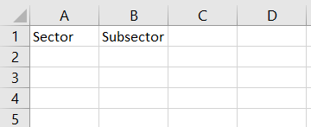Click on the **Empty** option to download an empty sector template (see below figure). The sector list is imported and exported in the CSV (Comma Separated Value) file format.

Click on the **With Data** option to download the sector master list.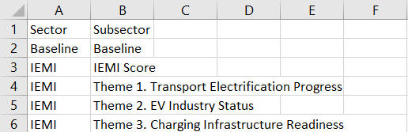

## **5.2 IMPORT**

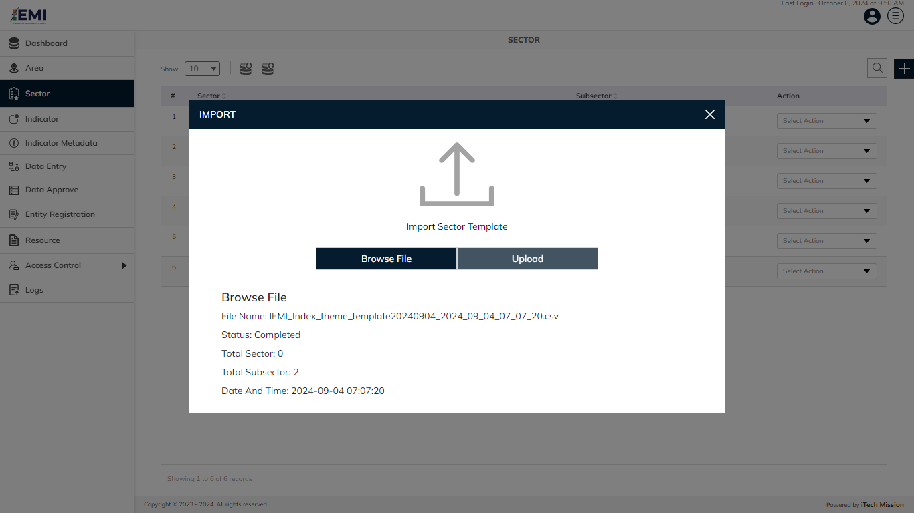Click on the **Import** button to browse the file and upload the sector master list into the database (see below figure).

To upload the sector into the database first enter the sector structure in the template as explained above and then click on the **Browse File** button to select the template. Now, click on the **Upload** button to start the import process. During the import process, the records which contain blank entries, entries with special characters and duplicate entries are not imported in the database.

A Last Upload summary will appear after the import process which provides the count of successfully imported records out of the total records. An error log will be generated to report on unsuccessfully imported records which you can access from the Logs module.

## **5.3 ADD**

Click on the **Plus** button available at the top right corner and enter the following information to add a new sector.

* Enter **Sector**
* Enter **Sub Sector 1**

Blue color details are mandatory to be entered. 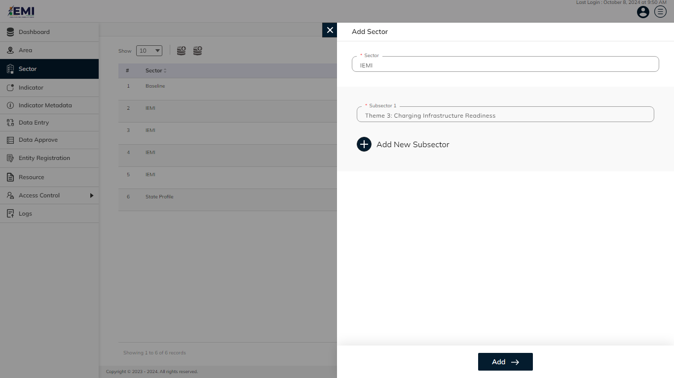Click on the **Add New Subsector** button to add more than one subsector. All details are mandatory to be entered. Click on the **Add** button to save and confirm. You can now view the new sector and subsector added in the sector list

Click to select the **Edit** option available in the action dropdown to edit the details of the selected sector. Edit the required detail and click on the update button to save and confirm.

Click to select the **Enable/Disable** option available in the action dropdown to show or hide the specific sector. The hidden sector will not be shown in the list of areas overall the application.

# 6.0 INDICATOR

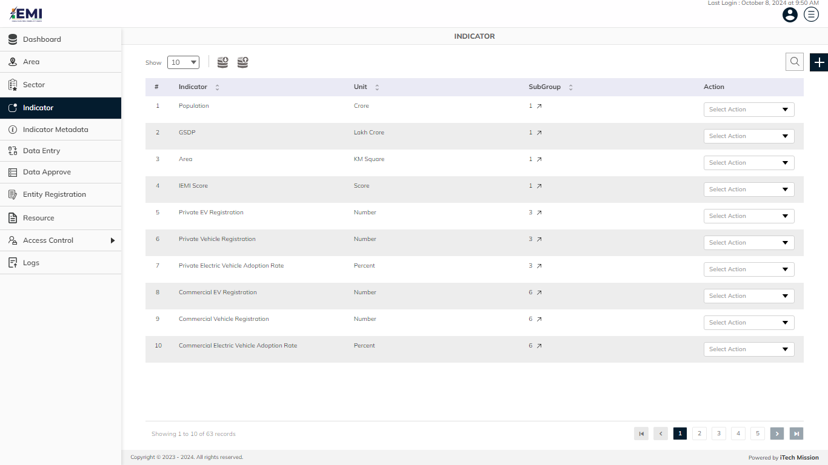Click on the **Indicator** menu option available in the left panel to access this module This module allows to manage the indicator master list. You will have options to export and import indicator template, add new indicator, view the list of existing indicators, sort the list, search indicator from the list, edit and enable/disable existing indicators (see below figure)

## **6.1 EXPORT**

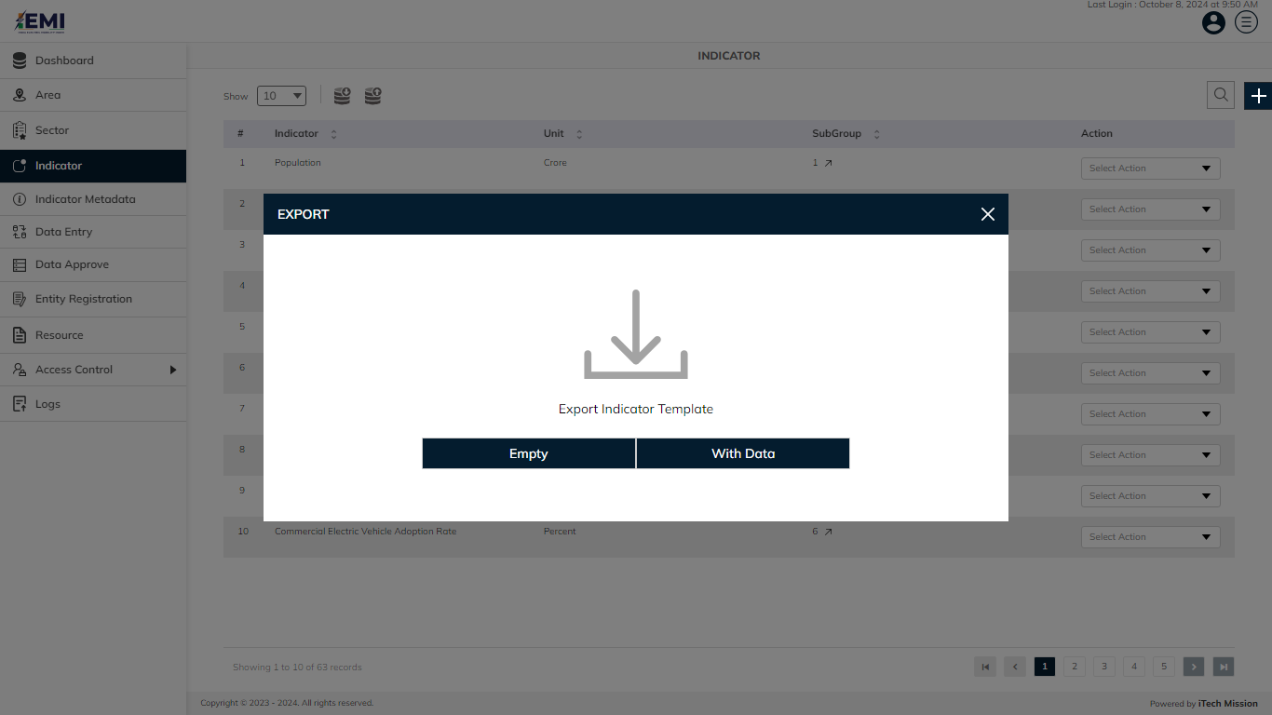Click on the **Export** button to download the empty indicator template and the indicator master list (see below figure).

You can use this option to create an indicator template structure. Below is the structure that you will find in the indicator empty template.

|  |  |
| --- | --- |
| **Index** | Index assigned to the indicator |
| **Theme** | Indicator classification by theme |
| **Indicator** | Name assigned to an indicator |
| **IndicatorType** | Indicator classification by type |
| **Unit** | Measurement unit of indicator |
| **Subgroup Dimension** | Dimension of the subgroup |
| **Subgroup** | Indicator disaggregation |
| **Subgroup Order** | Order of Indicator disaggregation |
| **IsDefaultSubgroup** | Select to store default of subgroups |
| **HighisGood** | Status to represent a good or bad indicator |

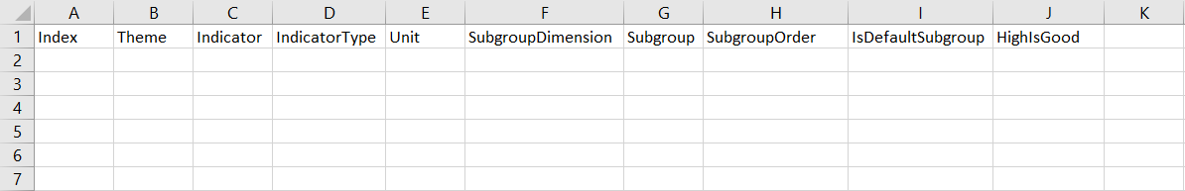Click on the **Empty** option to download an empty indicator template (see below figure). The indicator list is imported and exported in the CSV (Comma Separated Value) file format.

Click on the **With Data** option to download the indicator master list (see below figure)..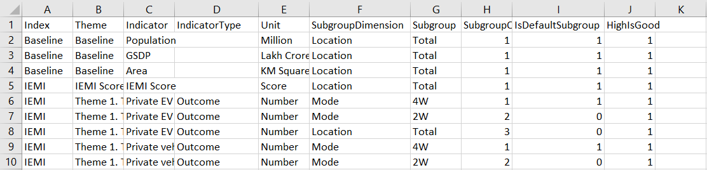

## 6.2 IMPORT

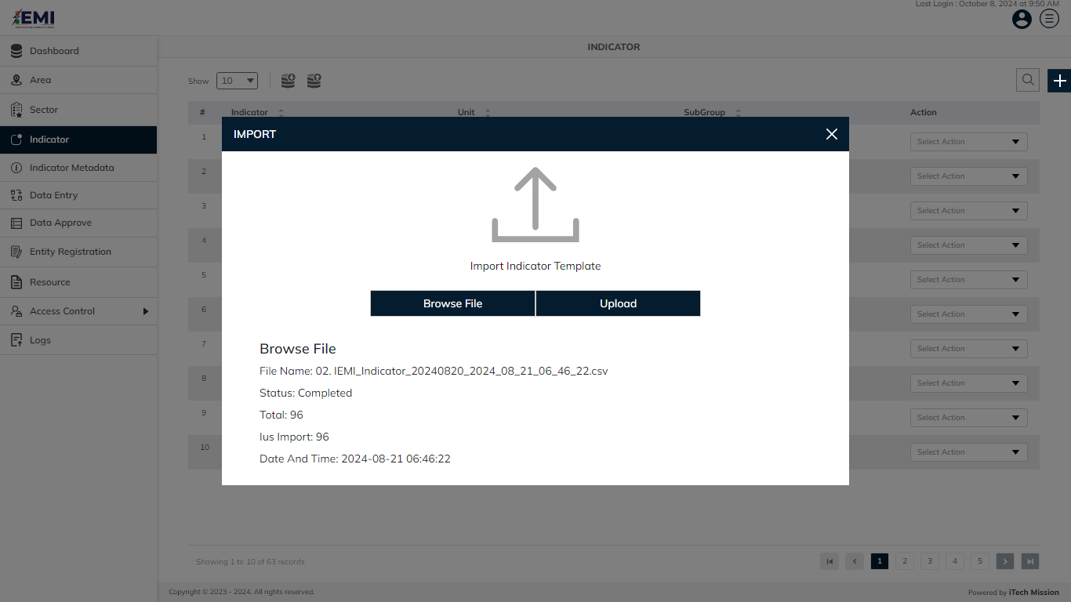Click on the **Import** button to browse the file and upload the indicator master list into the database (see below figure).

To upload the indicator into the database first enter the indicator structure in the template as explained above and then click on the **Browse File** button to select the template. Now, click on the **Upload** button to start the import process. During the import process, the records which contain blank entries, entries with special characters and duplicate entries are not imported in the database.

A Last Upload summary will appear after the import process which provides the count of successfully imported records out of the total records. An error log will be generated to report on unsuccessfully imported records which you can access from the Logs module.

## 6.3 ADD

Click on the **Plus** button available at the top right corner and enter the following information to add a new indicator.

**STEP 1**

* Enter Indicator
* Select **Unit**
* Select **High value is good** *(if the indicator is positive and look for higher value)*
* Enter **Minimum Value**
* Enter **Maximum Value**
* Select **Indicator Type**

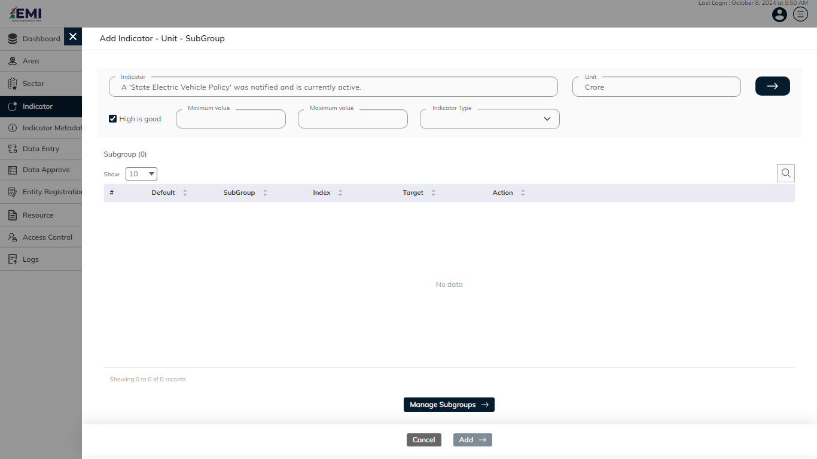Blue color details are mandatory to be entered. After entering indicator details, click on the **Manage Subgroups** button to associate subgroups to the indicator (see below figure).

**STEP 2**

* Subgroup Dimension(s).

**Additionally, you can perform below actions in this step**

Click on the **Plus** button to add a new subgroup dimension or its options.

Select subgroup dimension and then drag it using to change the sequence.

Click on the **Associated** checkbox, to view the list of all selected subgroup dimensions.

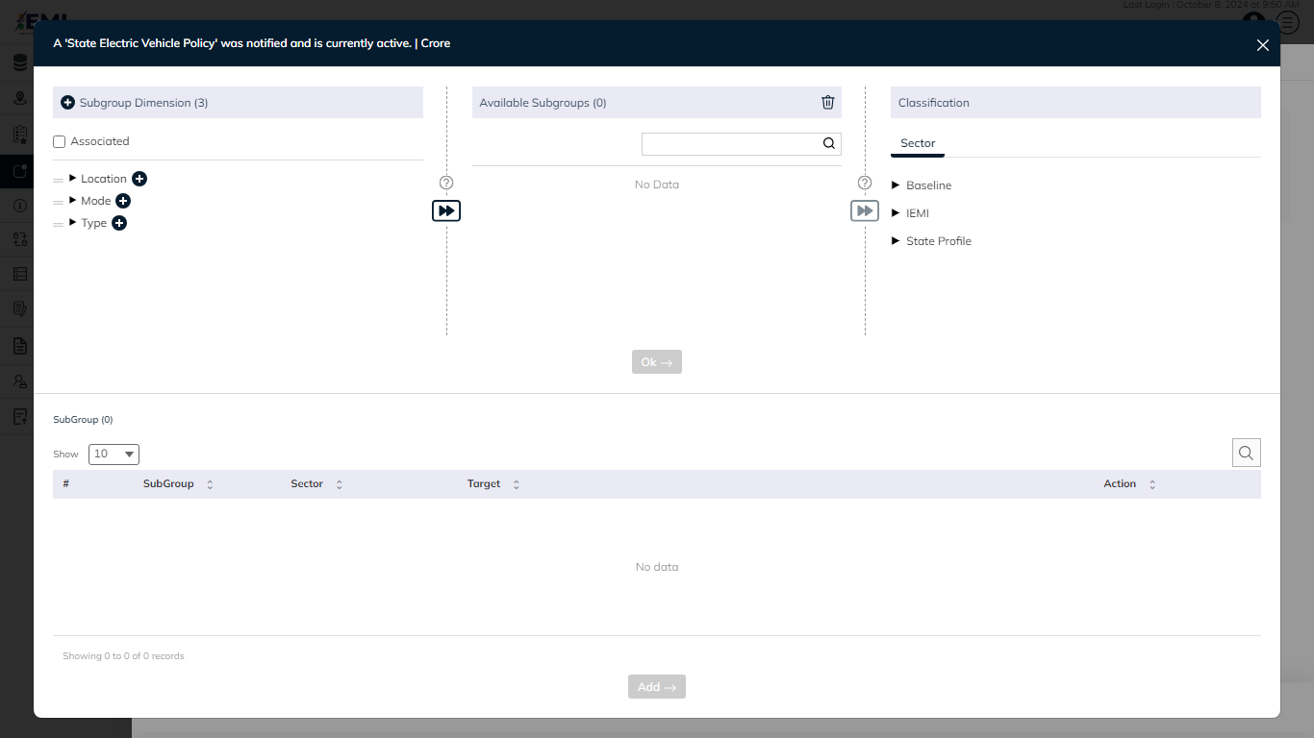Click on the **Forward** button to proceed to the next step (see figure below).

**STEP 3**

* Subgroup(s)

**Additionally, you can perform below action in this step**

Select subgroup(s) and then click on the **Delete** button to delete selected Subgroups.

Click on the **Search** option to search the elements in the subgroup list.

Click on the **Select All** checkbox, to select all subgroup(s) in the subgroup list at once.

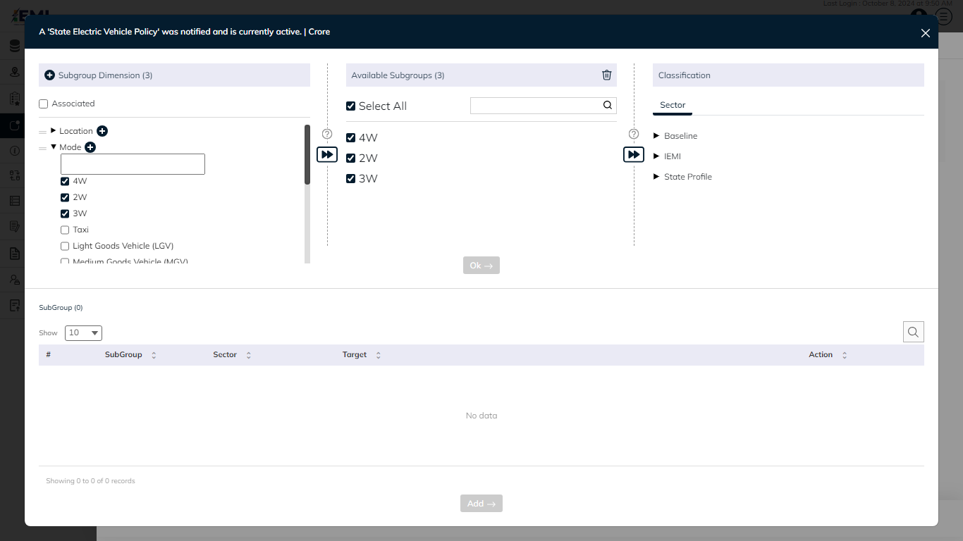Click on this **Forward** button to proceed to the next step.

**STEP 4**

* Sector

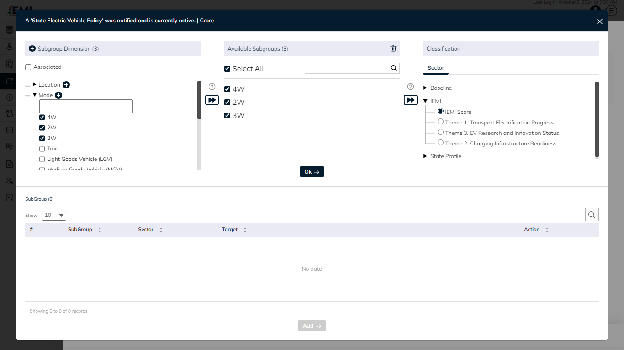Select the **Sector / Subsectors** to assign Indicator’s classification *(All indicators have to be associated with the sector).*

**Ok** button gets enabled once the sector is associated with subgroup(s). Click on **Ok** button to add subgroups to the list

Click on the **Delete** button available under the action column of the subgroups(s) list to remove the selected subgroup(s).

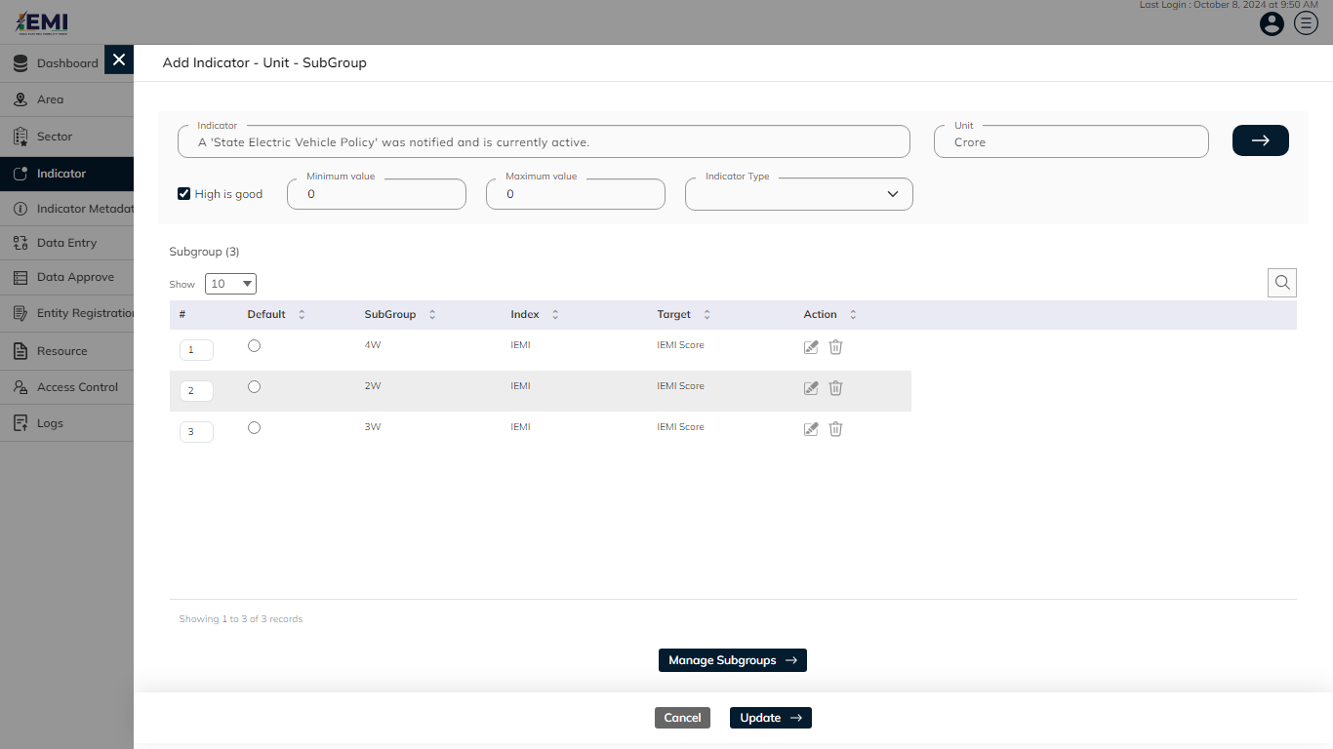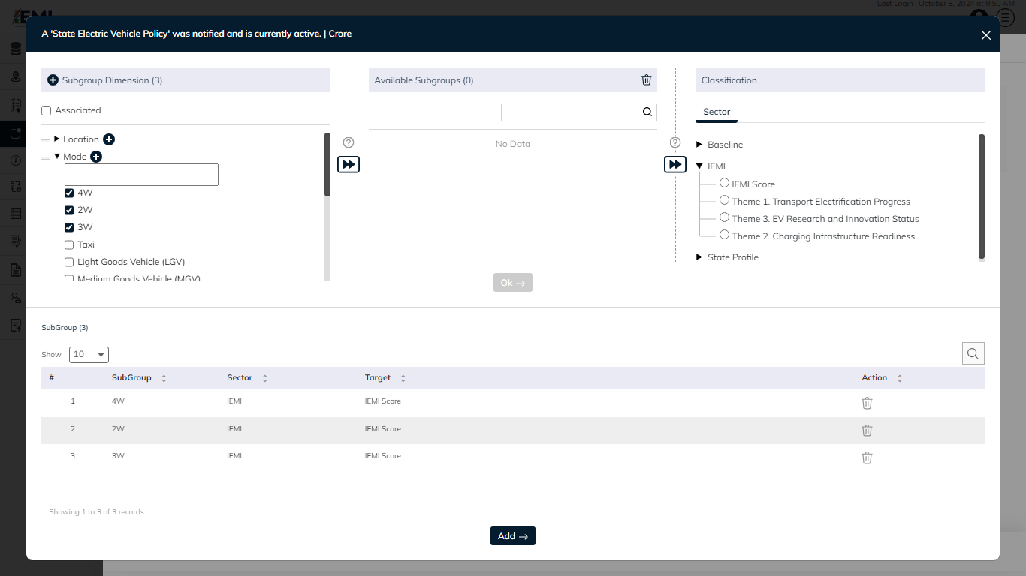Click on the **Add** button to confirm adding the selected subgroups(s). After clicking on Add button, you will switch back to the Add Indicator - Unit – Subgroup window.

In **Add Indicator - Unit – Subgroup** window

* Select if the subgroup Is Default Subgroup
* Enter Subgroup Order(s)
* Edit or Delete subgroup through options in action column

Click on the **Add** button to save and confirm. You can now view the new indicator added in the indicator list.

Click on the **Edit** option available in the dropdown under the action column to edit the details of the indicator. Edit the required detail and click on the update button to save and confirm.

# 7.0 INDICATOR METADATA

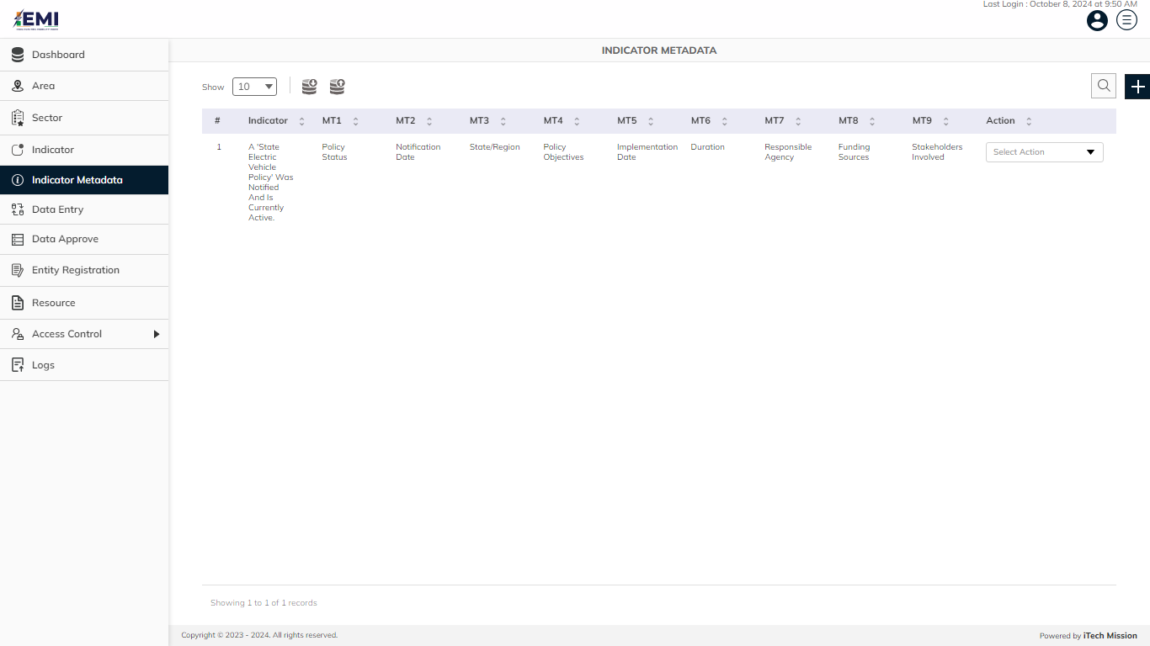Click on the **Indicator Metadata** menu option available in the left panel to access this module. This module allows to manage indicator’s metadata. You will have options to export and import indicator metadata template, add new indicator, view the list of existing indicator’s metadata, sort the list, search indicator metadata from the list, edit existing indicators metadata details (see below figure).

## **7.1 EXPORT**

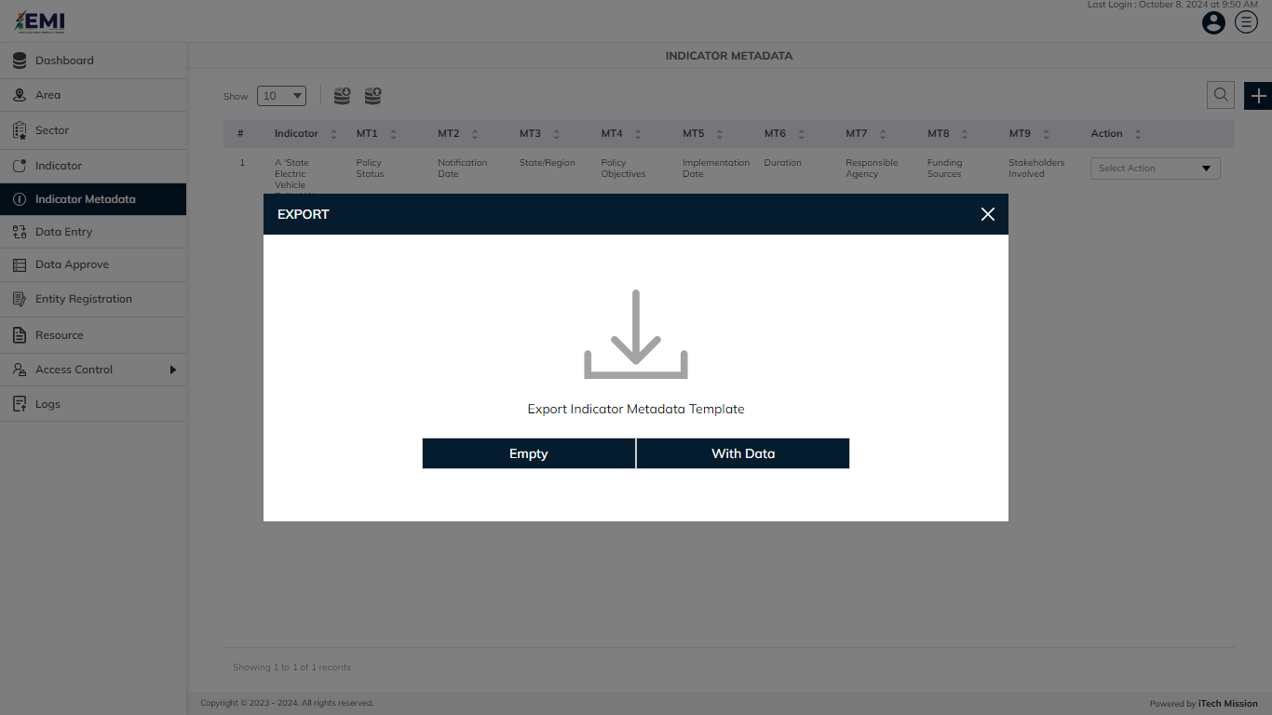Click on the **Export** button to download the empty indicator metadata template and the metadata master list (see below figure).

You can use this option to create an indicator metadata template structure. Below is the structure that you will find in the indicator metadata empty template.

|  |  |
| --- | --- |
| **Indicator** | Name of the indicator |
| **Unit** | Measurement unit of indicator |
| **MT1** | The definition of the selected indicator |
| **MT2** | The computation description for the indicator |
| **MT3** | The overview of the indicator |
| **MT4** | The comments and limitations of the indicator |
| **MT5** | The detail of data collection for data monitoring |
| **MT6** | The name of the data source of the availability of data. |
| **MT7** | The treatment method of missing values |
| **MT8** | The regional and global estimate of selected Indicator |
| **MT9** | The definition of the selected indicator |

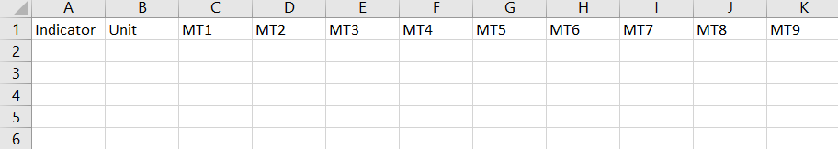Click on the **Empty** option to download an empty indicator metadata template (see below figure). The indicator metadata is imported and exported in the CSV (Comma Separated Value) file format.

Click on the **With Data** option to download the indicator metadata master list.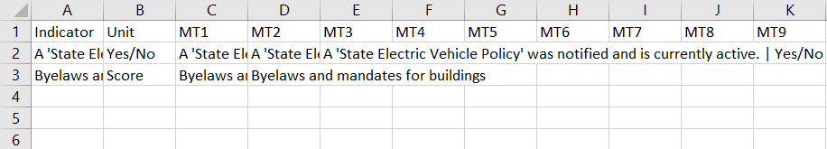

## **7.2 IMPORT**

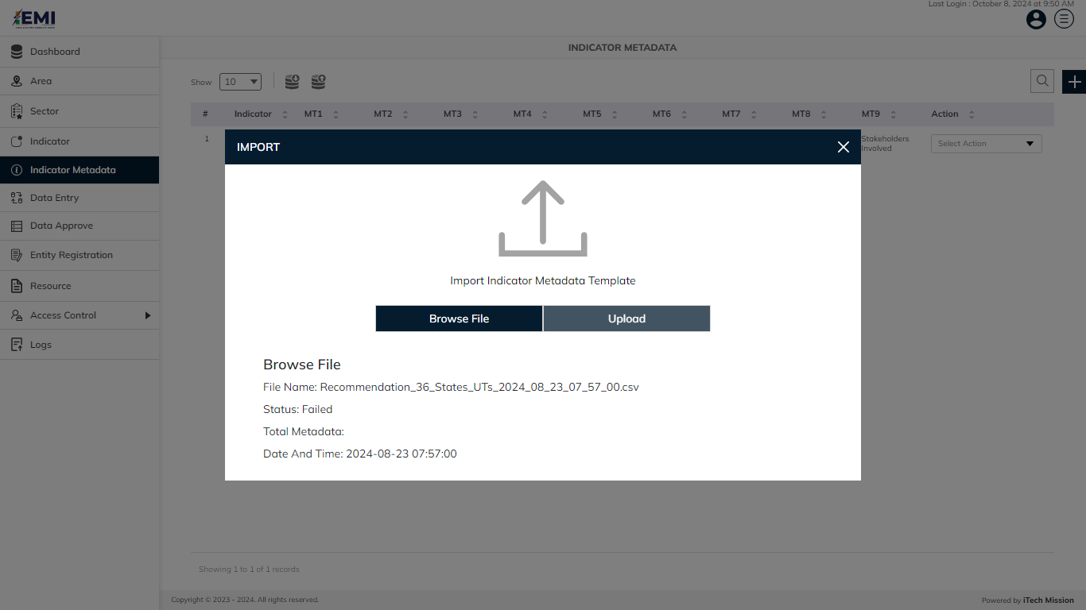Click on the **Import** button to browse the file and upload the indicator metadata master list into the database (see below figure).

To upload the indicator metadata into the database first enter the metadata structure in the template as explained above and then click on the **Browse File** button to select the template. Now, click on the **Upload** button to start the import process. During the import process, the records which contain blank entries, entries with special characters and duplicate entries are not imported in the database.

A Last Upload summary will appear after the import process which provides the count of successfully imported records out of the total records. An error log will be generated to report on unsuccessfully imported records which you can access from the Logs module.

## **7.3 ADD**

Click on the **Plus** button available at the top right corner and enter the following information to add a new indicator metadata.

* Select **Indicator | Unit**
* Enter **Indicator Definition**
* Enter **MT1** *(Method of computation)*
* Enter **MT2** *(Overview of the indicator)*
* Enter **MT3** *(Comments and Limitations)*
* Enter **MT4** *(Data source of the availability of data)*
* Enter **MT5** *(Data collection for data monitoring)*
* Enter **MT6** *(Treatment method of missing values)*
* Enter **MT7** *(Regional and global estimate of selected Indicator)*

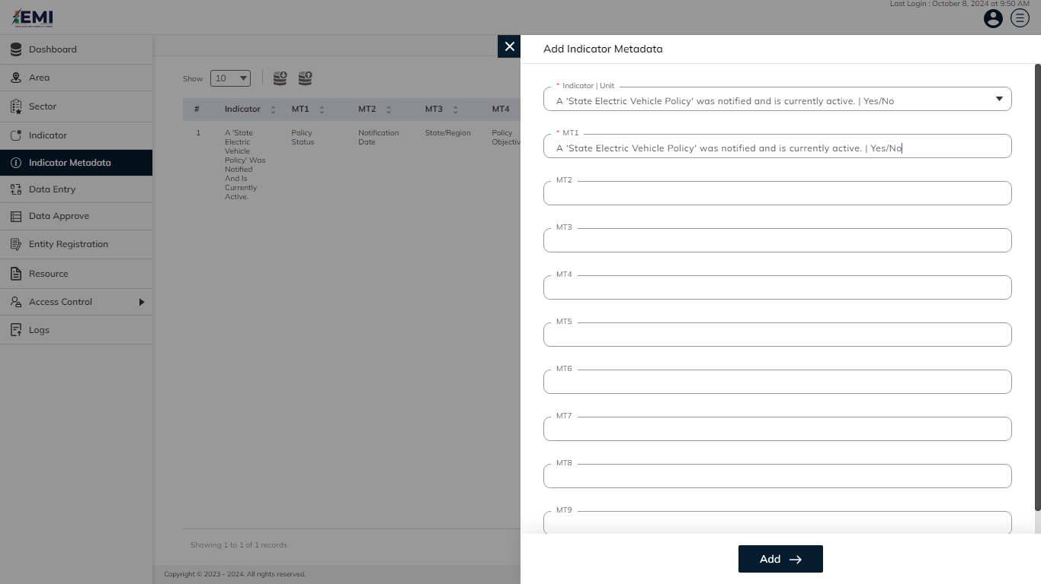Blue color details are mandatory to be entered. Click on the **Add** button to save and confirm. You can now view the indicator metadata added to the Indicators Metadata list.

Click on the **Edit** option available in the dropdown under the action column to edit the details of the indicator metadata. Edit the required detail and click on the update button to save and confirm.

# 8.0 DATA ENTRY

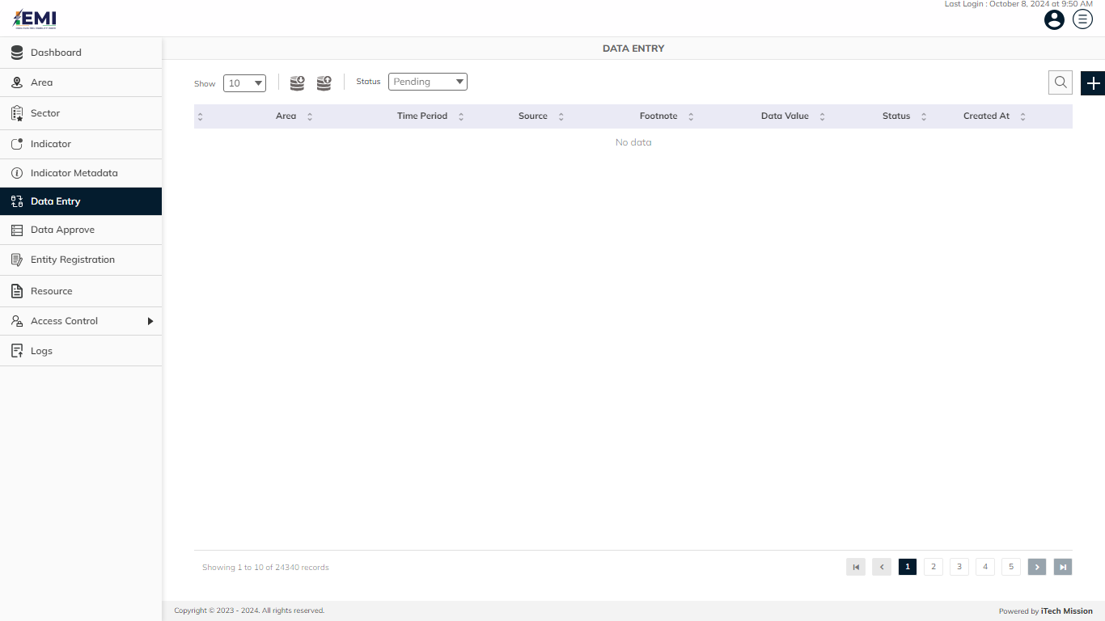Click on the **Data Entry** option available in the left panel to access this module. This module allows us to manage the master data. You will have options to export and import data templates, view the list of existing data, update and delete the existing data (see figure below).

## **8.1 EXPORT**

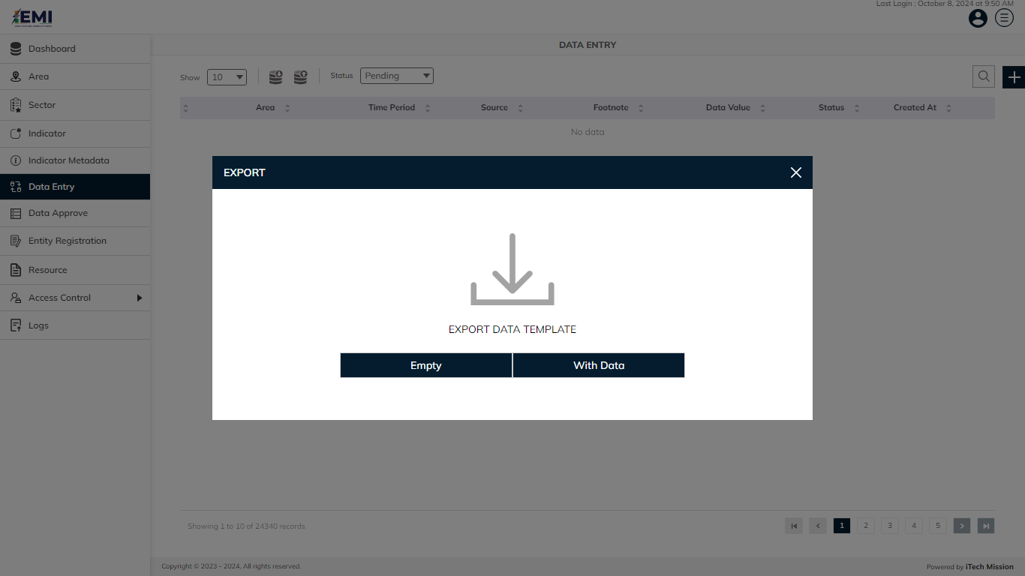Click on the **Export button** to download the empty data entry template and the data master list (see below figure).

You can use this option to create a data template structure. Below is the structure that you will find in the data empty template.

|  |  |
| --- | --- |
| **AreaID** | Area ID of the data |
| **AreaName** | Area Name of the data |
| **Time period** | Data for the selected time period |
| **Source** | Source of the data |
| **Indicator** | Indicator of the data |
| **Unit** | Measurement unit of the indicator selected |
| **Subgroup** | Subgroup of the data |
| **Data Value** | Value assigned to the data |
| **Footnote** | Footnote for the data |

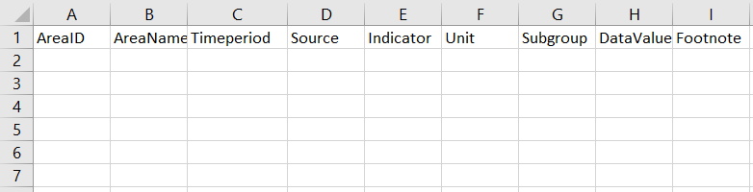Click on the **Empty** option to download an empty indicator metadata template (see below figure). The indicator metadata is imported and exported in the CSV (Comma Separated Value) file format.

Click on the **With Data** option to download the data master list.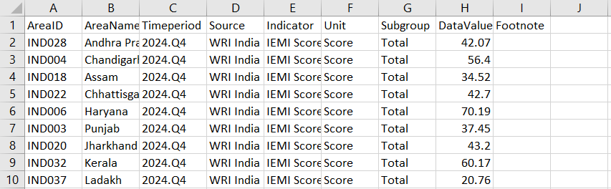

## **8.2 IMPORT**

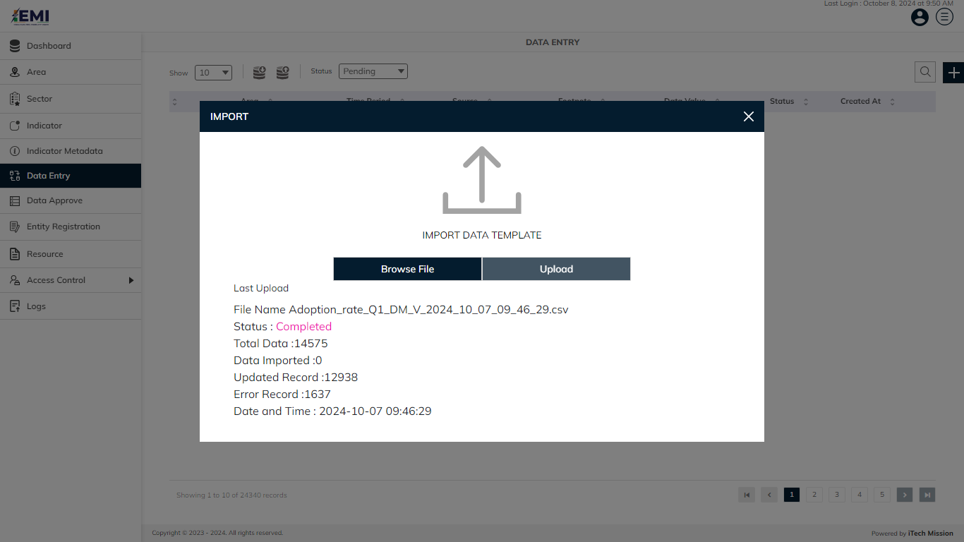Click on the **Import** button to browse the file and upload the data master list into the database (see below figure).

To upload the data into the database first enter the data structure in the template as explained above and then click on the **Browse File** button to select the template. Now, click on the **Upload** button to start the import process. During the import process, the records which contain blank entries, entries with special characters and duplicate entries are not imported in the database.

A Last Upload summary will appear after the import process which provides the count of successfully imported records out of the total records. An error log will be generated to report on unsuccessfully imported records which you can access from the Logs module.

## **8.3 ADD**

Click on the **Plus** button available at the top right corner and enter the following information to add a new data record.

* Select **Indicator I Unit**
* Select **Subgroup**
* Select **Area**
* Enter **Time period**
* Enter **Sourc**e
* Enter **Data Value**
* Enter **Footnote**

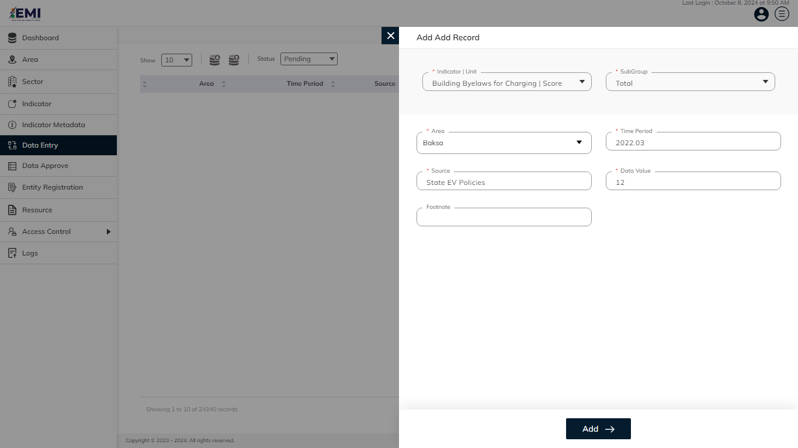Blue color details are mandatory to be entered. Click on the **Add** button to save and confirm. You can now view the new data record added in the pending list.

Click to select **Edit** option available in the action dropdown to edit the details of the selected data record. Edit the required detail and click on the update button to save and confirm.

Click to select the **Delete** option available in the action dropdown to delete the selected data record. A confirmation popup will appear, click yes to confirm deletion of selected data record.

**NOTE:**

The options to edit and delete are only available for the data records which are in Pending or Disapproved state. You can also view the reason for disapproval of the data records by clicking on the **Eye** button available under the remarks column of each disapproved data.

# 9.0 DATA APPROVE

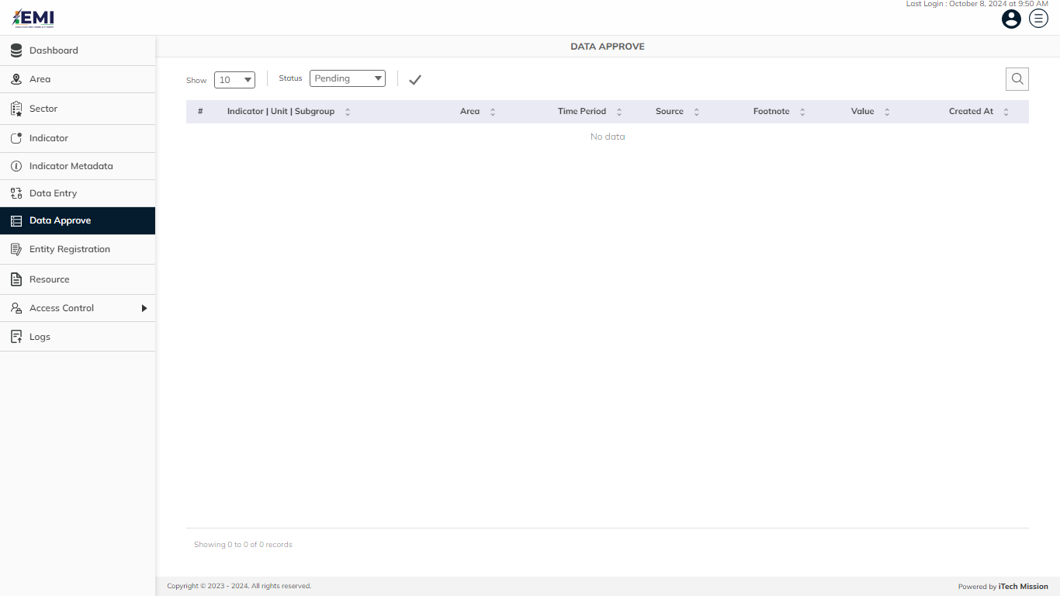Click on the **Data Approve** option available in the left panel to access this module. This module allows to manage approval of the added/updated data records. You will have the option to approve the pending data which has been added or updated using the Data Entry module (see below figure).

In order to approve a pending record, click on the **Approve** optionavailable for each pending data record in the action column. The data record will be moved to the approved list and it can now be viewed on the user interface application.

In order to disapprove a pending record, click on the **Disapprove** optionavailable for each pending data record in the action column. You will be asked to confirm the disapproval and you can also add remarks for disapproval of the respective data record.

In order to approve all data records at once, click on the **Approve All Data** option available at the top left corner of the page in status.

# 10.0 ENTITY REGISTRATION

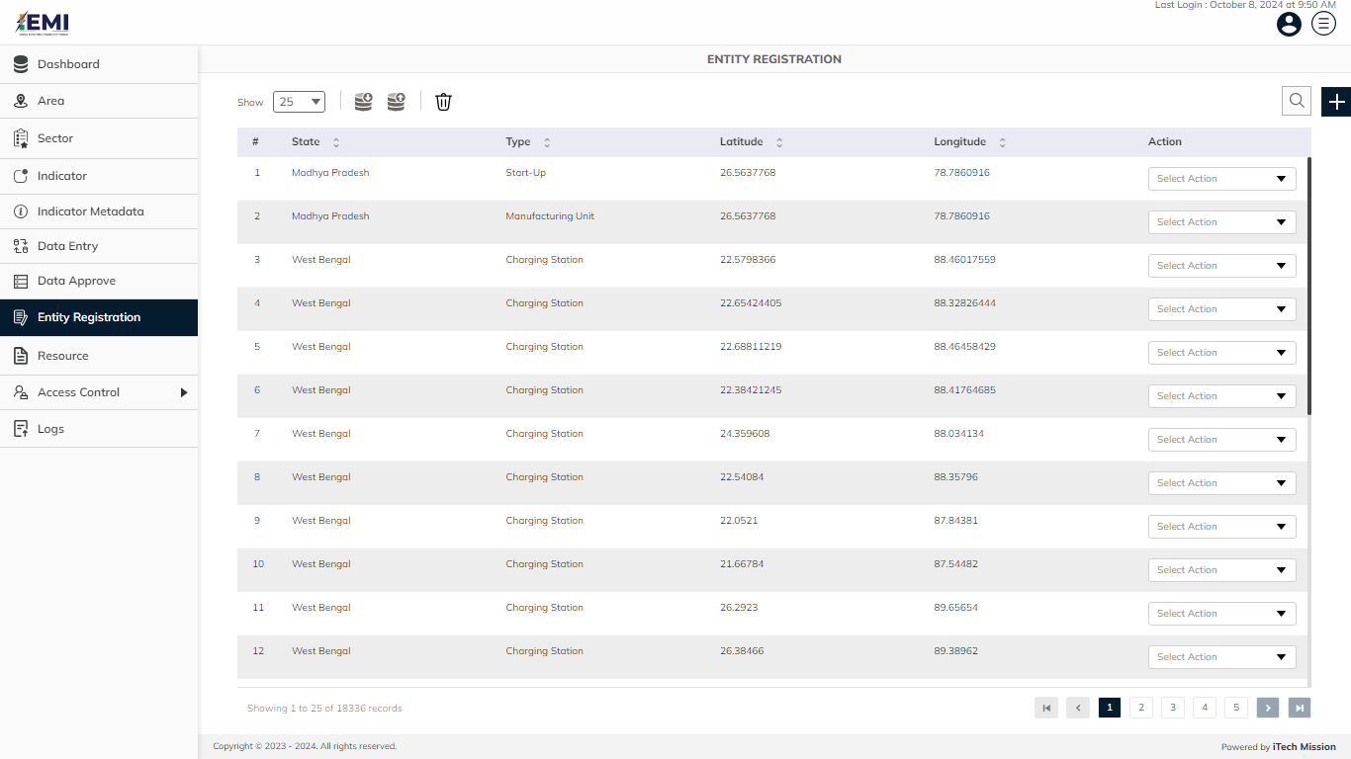Click on the **Entity Registration** option available in the left panel to access this module. This module allows to manage entity (Manufacturing Unit, Charging Station and Start Ups) registration in the database. You will have options to export and import entity registration template, add new entity, view the list of existing entities, sort the list, search entity from the list, edit and enable/disable existing entity (see below figure).

## **10.1 EXPORT**

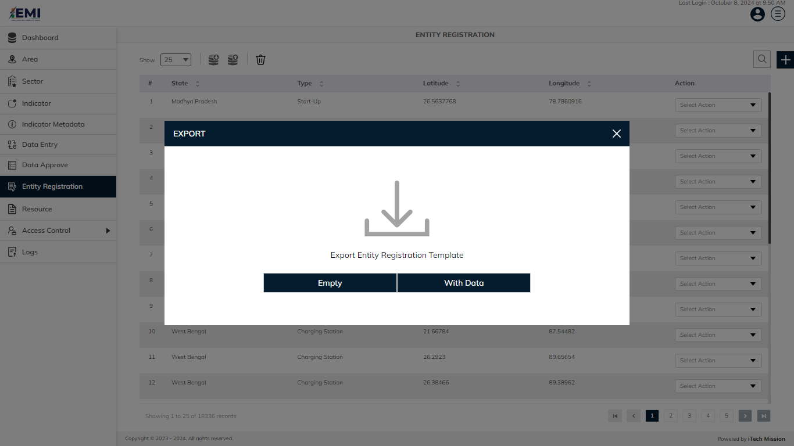Click on the **Export button** to download the empty data entry template and the data master list (see below figure).

You can use this option to create an entity registration template structure. Below is the structure that you will find in the entity registration empty template.

|  |  |
| --- | --- |
| **Type** | Type of the entity as Manufacturing Unit, Charging Station or Start Ups |
| **AreaName** | Area Name of the entity |
| **Name** | Name of the entity |
| **CityName** | Name of the city |
| **Lat** | Latitude of the area/location |
| **Long** | Longitude of the area/location |
| **Description** | Description of the entity |

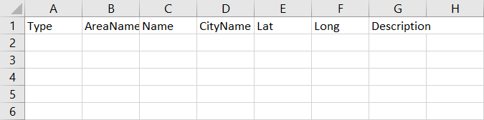Click on the **Empty** option to download an empty entity registration template (see below figure). The entity is imported and exported in the CSV (Comma Separated Value) file format.

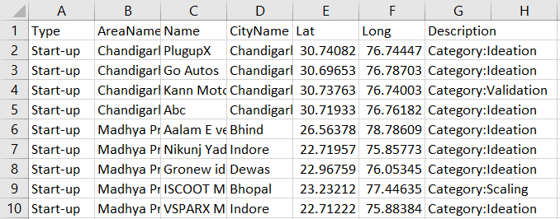Click on the **With Data** option to download the entity registration master list.

## **10.2 IMPORT**

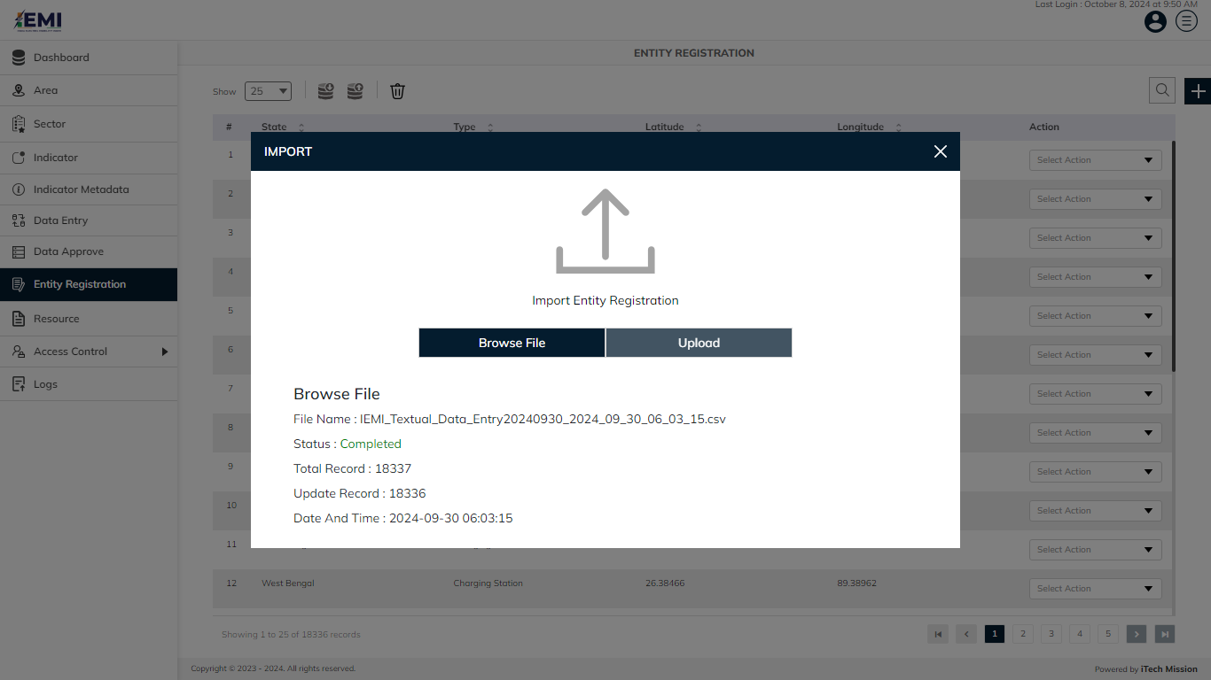Click on the **Import** button to browse the file and upload the entity master list into the database (see below figure).

To upload the entity master data into the database first enter the entity data structure in the template as explained above and then click on the **Browse File** button to select the template. Now, click on the **Upload** button to start the import process. During the import process, the records which contain blank entries, entries with special characters and duplicate entries are not imported in the database.

A Last Upload summary will appear after the import process which provides the count of successfully imported records out of the total records. An error log will be generated to report on unsuccessfully imported records which you can access from the Logs module.

## **10.3 ADD**

Click on the **Plus** button available at the top right corner and enter the following information to add a new entity.

* Select **Type**
* Select **State**
* Select **City**
* Enter **Name**
* Enter **Latitude**
* Enter **Longitude**
* Enter **Description**

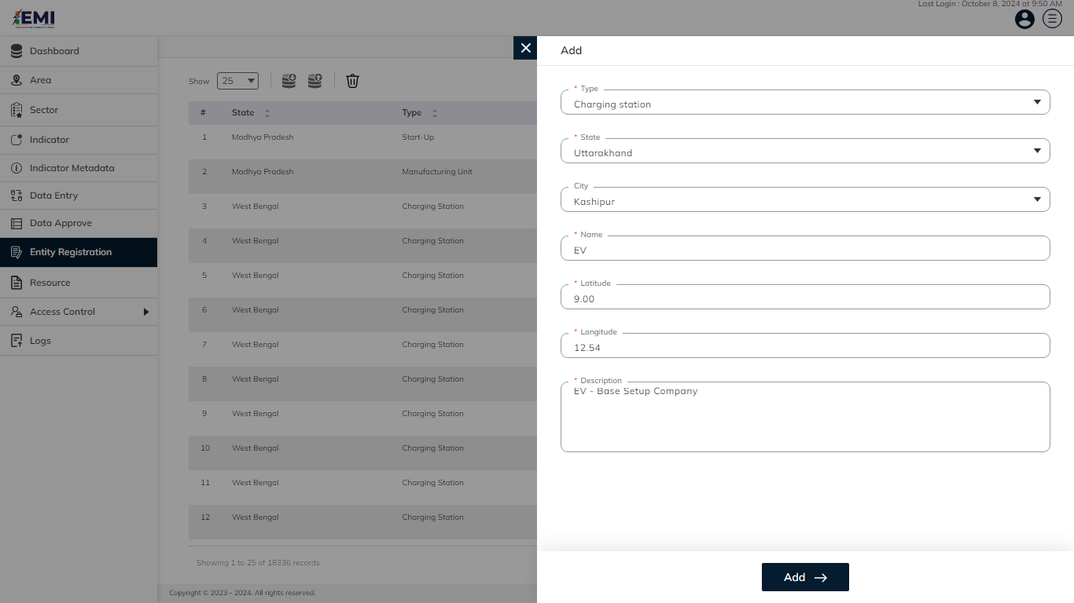All the details are mandatory to add a new entity. Click on the **Add** button to save and confirm. You can now view the new data record added in the pending list

Click on the **Edit** option available in the dropdown under the action column to edit the details of the entity. Edit the required detail and click on the update button to save and confirm.

Click on the **Delete** option available in the dropdown under the action column to delete the selected element. A confirmation popup will appear, click yes to confirm the deletion.

# 11.0 RESOURCE

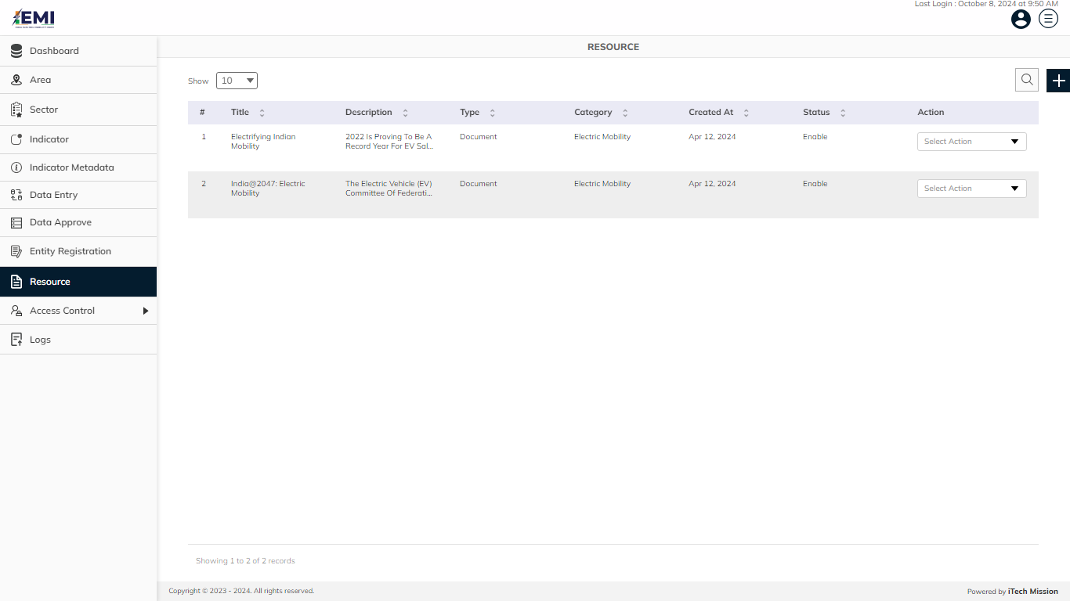Click on the **Resource** option available in the left panel to access this module. This module allows to manage resources list. You will have options to add new resources, view the list of existing resources, search resources from the list, edit, delete and enable/disable existing resources from the list (see below figure).

Click on the **Plus** button available at the top right corner and enter the following information to add a new resource.

* Enter **Resource Name**
* Enter **Resource Description**
* Select **Resource Type** (Document or Link)
* Upload **Document** (In case the resource type is Document)
* Enter **UR**L (In case the resource type is URL)
* Enter **Category**
* Upload **Image**

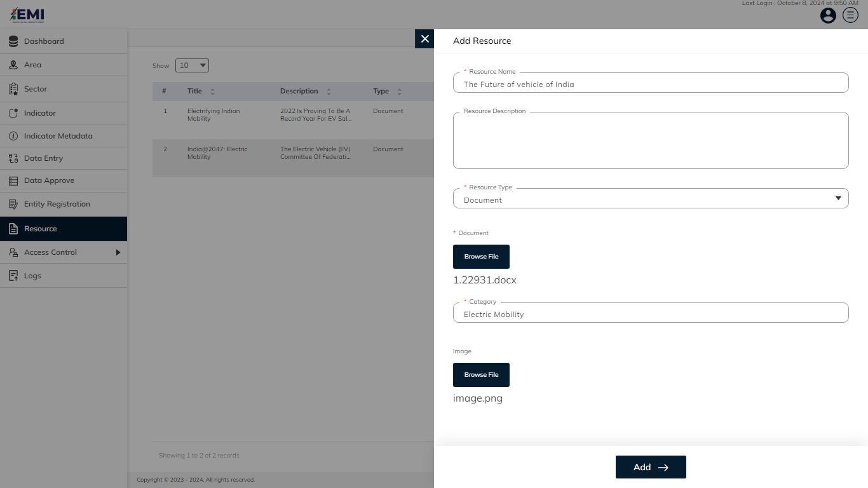Blue color details are mandatory to be entered to add a new resource. Click on the **Add** button to save and confirm. You can now view the new resource in the resource list and Downloads module of the user interface application.

Click on the **Edit** option available in the dropdown under the action column to edit the details of the resource. Edit the required detail and click on the update button to save and confirm.

Click on the **Delete** option available in the dropdown under the action column to delete the selected element. A confirmation popup will appear, click yes to confirm the deletion.

Click on the **Enable/Disable** option available in the dropdown under the action column to enable or disable the resource. The disabled element will not be shown in the user interface application.

# 12.0 ACCESS CONTROL

Click on the **Access Control** option available in the left panel to access this module. This module allows us to manage the Roles and Permissions and User .

Click on Access Control to select from – **Roles and Permissions** and **User.** (see figure below).

## **12.1 ROLES AND PERMISSIONS**

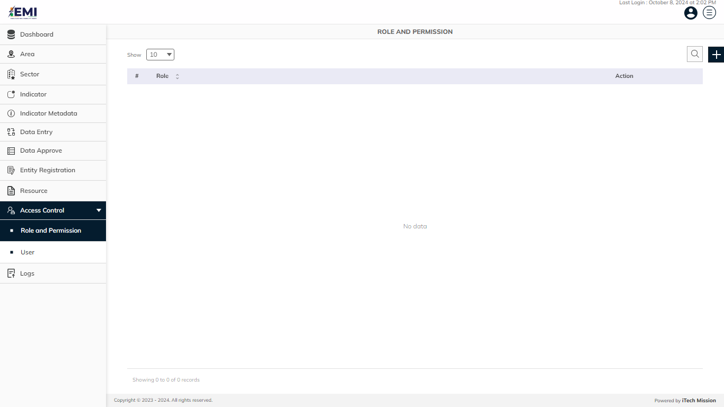Click on the **Roles and Permissions** option available under **Access Control** in the left panel to access this module. This module allows to manage Roles list and Permissions assigned. You will have options to add new roles, view the list of existing roles, search users from the list, edit and Enable/Disable existing roles (see figure below).

Click on the **Plus** button available at the top right corner and enter the following information to add a new user.

* Enter Role
* Check Permissions *(View, Add/Edit, Delete, Show/Hide)*.

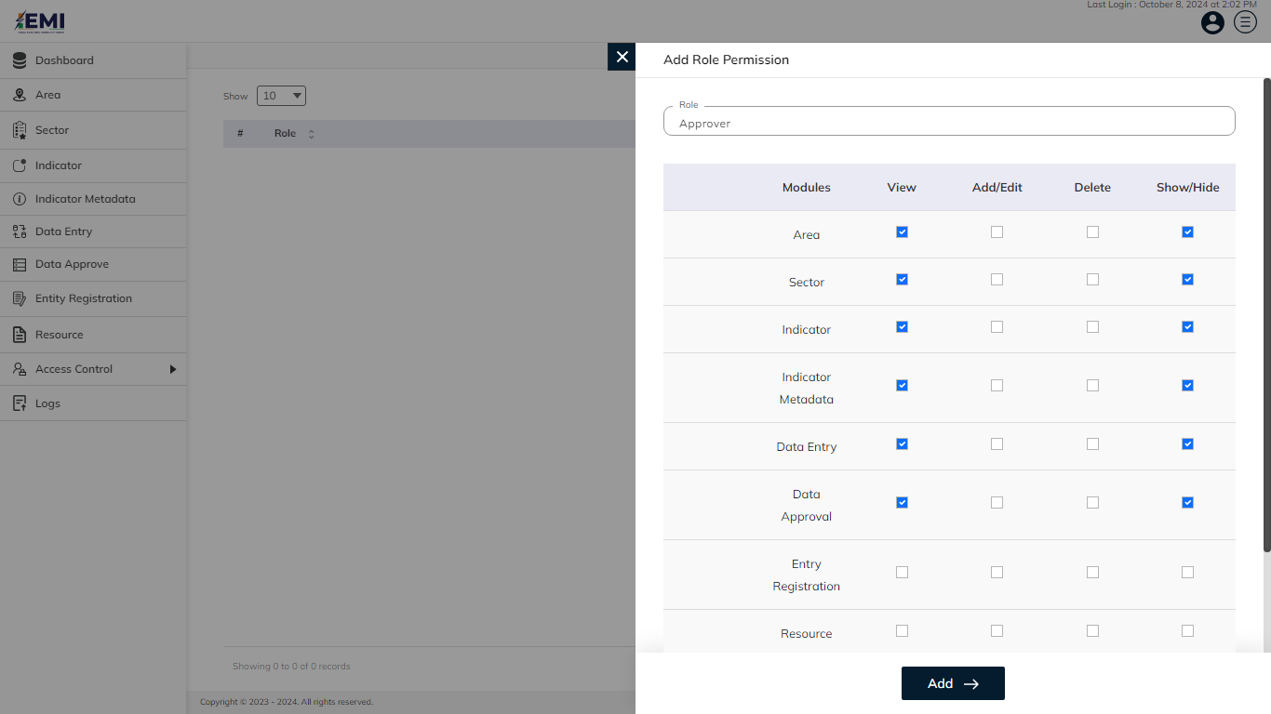All details are mandatory to be entered to add a new user. Click on the **Add** button to save and confirm. You can now view the new role added in the Roles list.

Click on the **Edit** option available in the dropdown under the action column to edit the details of the user. Edit the required detail and click on the update button to save and confirm.

Click on the **Delete** option available in the dropdown under the action column to delete the selected element. A confirmation popup will appear, click yes to confirm the deletion.

Click on the **Enable/Disable** option available in the dropdown under the action column to enable or disable the user. The disabled user will not be able to login into the portal.

## **12.2 USER**

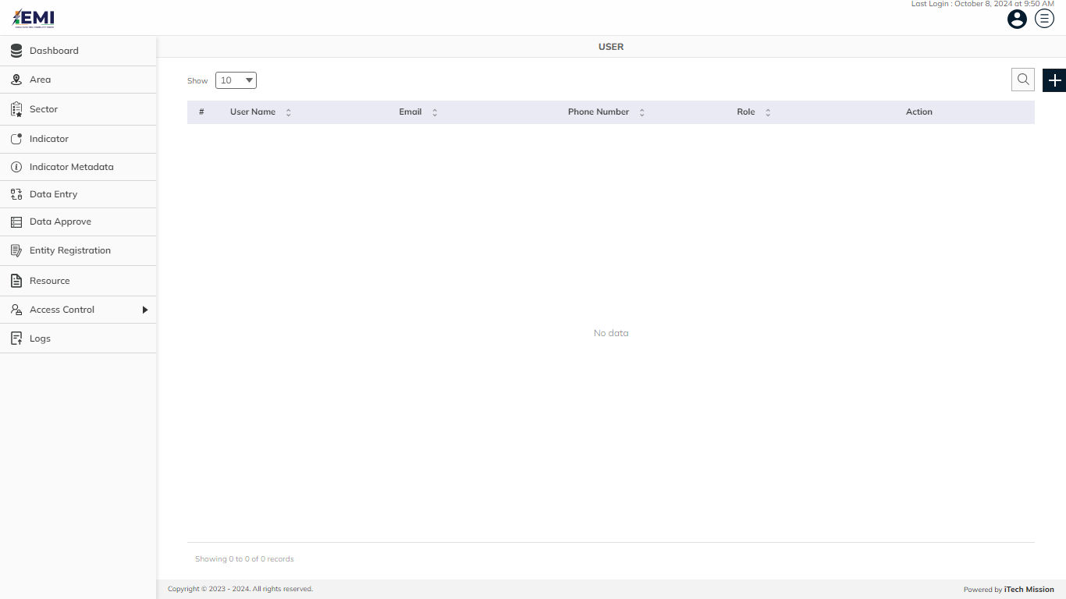Click on the **User** option available in the left panel to access this module. This module allows to manage users list. You will have options to add new users, view the list of existing users, search users from the list, edit and Enable/Disable existing users (see figure below).

Click on the **Plus** button available at the top right corner and enter the following information to add a new user.

* Enter **User Name**
* Enter **Email**
* Enter **Phone Number**
* Select **Area**
* Select **Role**
* Set **Password**

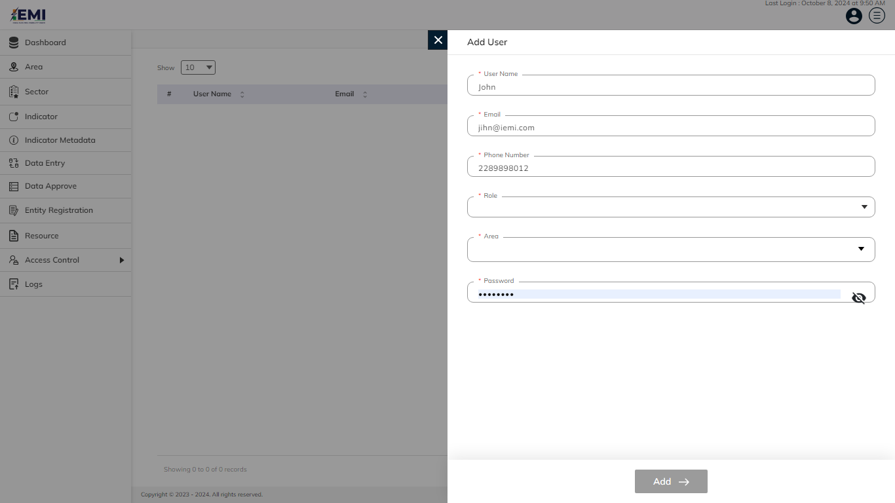All details are mandatory to be entered to add a new user. Click on the **Add** button to save and confirm. You can now view the new user added in the user list.

Click on the **Edit** option available in the dropdown under the action column to edit the details of the user. Edit the required detail and click on the update button to save and confirm.

Click on the **Delete** option available in the dropdown under the action column to delete the selected element. A confirmation popup will appear, click yes to confirm the deletion.

Click on the **Enable/Disable** option available in the dropdown under the action column to enable or disable the user. The disabled user will not be able to login into the portal.

# 13.0 LOGS

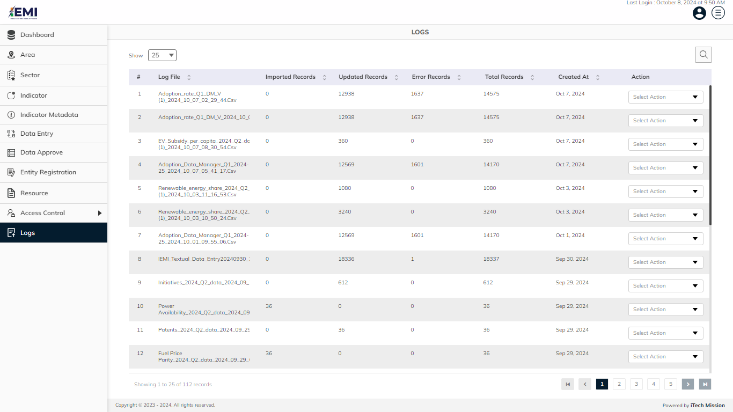Click on **Logs** from the menu option in the left panel to access this module. This module allows to manage the Import Log master list. You will have options to view the list of existing logs, download and view log reports and delete selected logs (see below figure).

A log will be generated when any data template is imported into the database. A list of import logs is shown on this page where each import log is shown as a row. You can view the file name of each import log along with the log summary that includes: count of records imported, count of records updated, count of error records, total records available in the import file and date & time of the import. You also have the options to download the log file in order to view the reason of error records. The log file will be downloaded in CSV format.

Click on the **Download** option available in the dropdown under the action column to download the logs.

Click on the **Delete** option available in the dropdown under the action column to delete the selected element. A confirmation popup will appear, click yes to confirm the deletion.

---- End of the Document ----